Credits
This section will provide a screen shot(s) of the Credit tab from the ‘BUG Mod Options’ screen (below).
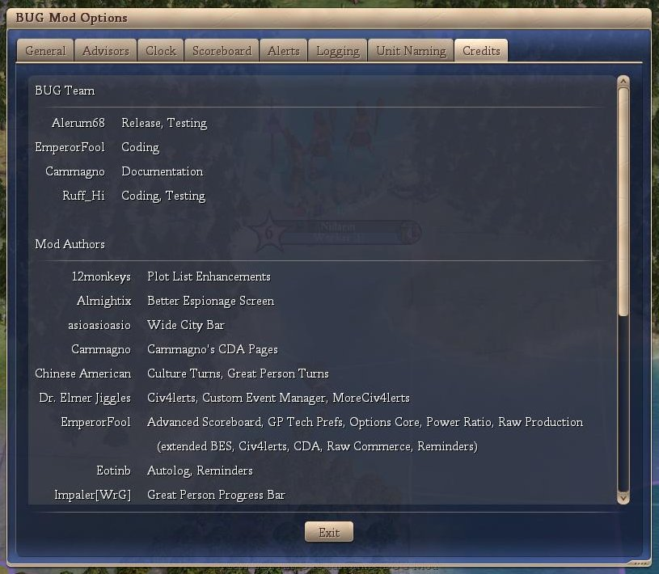
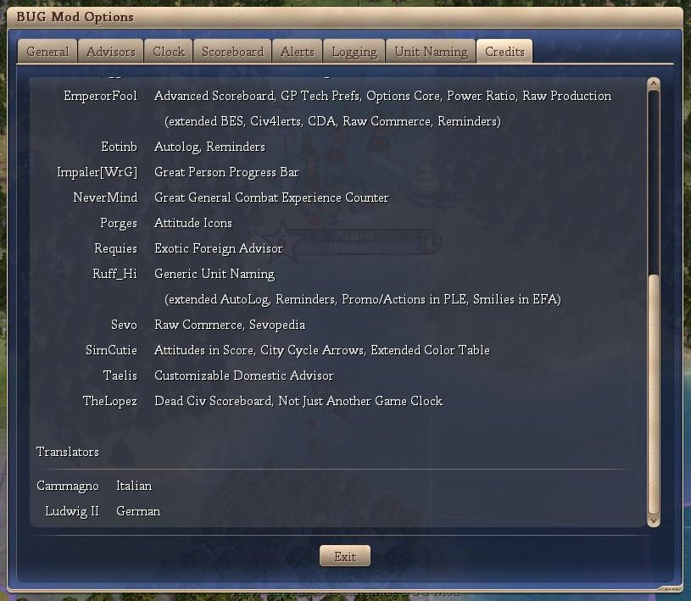

Conclusion
Opinion: No approval required, no spoiler information provided.

